The Problem | The Set-Up | The Work
- How tall is the building?  Hypotenuse – green  Opposite – purple  Adjacent - pink | Highlight indicated parts.  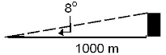
- A kite in the sky is attached to a 155 m long string. The string forms a 73˚ angle with the ground. How high above the ground is the kite?  Hypotenuse – green  Opposite – purple  Adjacent - pink | Highlight and fill in known values.  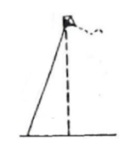
- A ladder meets a building 11.3 feet above the base of the building and forms a 70 ˚ angle with the ground. How long is the ladder?  Hypotenuse – green  Opposite – purple  Adjacent - pink | 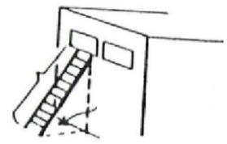  Highlight and fill in known values.
- A rock dropped from the top of the Leaning Tower of Pisa falls to a point 14 feet from its base. If the tower is 182 feet tall (vertical height), at what angle does it lean at the ground?  Hypotenuse – green  Opposite – purple  Adjacent - pink | Highlight and fill in known values.  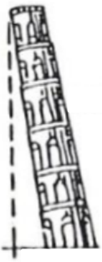
The Problem | The Set-Up | The Work
- A mine shaft is 300 m deep and makes an angle of 65°  with the horizontal ground. How long is the shaft?  Hypotenuse – green  Opposite – purple  Adjacent - pink | Draw the situation on the ∆.  Highlight and fill in information.  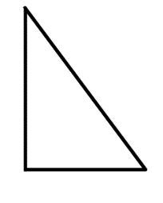
- A 90-foot escalator rises 28 feet vertically. What is the angle that the escalator makes with the floor?  Hypotenuse – green  Opposite – purple  Adjacent - pink | Draw the triangle, highlight and  Fill in information.
- Sonar on a destroyer detects a submarine at a depth of 200 m. If the angle is 31°, how far apart are the two vessels?  Hypotenuse – green  Opposite – purple  Adjacent - pink | Depict the situation, highlight, and fill in known values.
- Challenge: A ladder is mounted on a fire truck, six feet above the ground. If the maximum length of the ladder is 120 feet and the maximum angle to which it can be raised is 75°, how high up will it reach?  Hypotenuse – green  Opposite – purple  Adjacent - pink | Depict the situation, highlight, and fill in known values.

