Math 2 **HW: Standard Form** Unit 3*.*

|  |  |  |  |  |  |
| --- | --- | --- | --- | --- | --- |
| **Quadratic Functions** | **Problem 1:** | **Problem 2:** | **Problem 3:** | **Problem 4:** | **Problem 5:** |
| **Direction of Opening:** |  |  |  |  |  |
| **Axis of Symmetry:**    *or the x-value of the vertex* |  |  |  |  |  |
| **Vertex:**  *Solve by hand or find max/min in the calculator* |  |  |  |  |  |
| **Y-Intercept:**  (0, c) |  |  |  |  |  |
| **Domain:**  *x-values of the graph* |  |  |  |  |  |
| **Range:**  *y-values of the graph* |  |  |  |  |  |

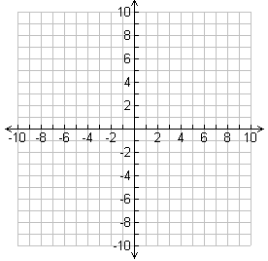 Example 1: Example 3:

 Example 2: Example 4: