*** You may need to use extra notebook paper to factor each problem.***
1. A cardboard box has the following volume measured in ft³: 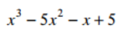. What three polynomial expressions could represent the dimensions of the box? | 2. 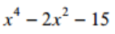 | 3. –x⁴ + 17x² - 16
4. 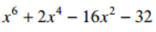 | 5. 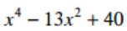 | 6. 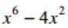
7. 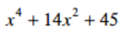 | 8. 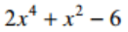 | 9. 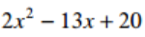

10. 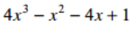 | 11. 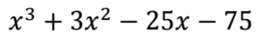 | 12. 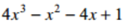
13. 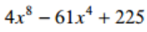 | 14. The area of a parallelogram measures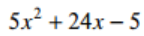 cm². What are the base and height of the parallelogram? | 15. 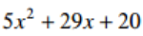
16. 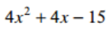 | 17. 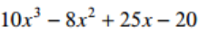 | 18. 